Assignment 2 Final Report

Table of Contents
Introduction 3
Background 5
References 7
Appendix 8

Introduction
The primary objective of this project is to investigate and implement classification algorithms leveraging PyTorch, with a specific focus on recognising handwritten digits. This task holds significant importance as it emulates applications akin to the US Postal Service’s mail sorting system, which utilises similar technology. Handwritten digit recognition has many real-world applications, including Optical Character Recognition (OCR), automated form processing, and digitised archival systems.
Problem Domain:
The central problem revolves around accurately classifying images of handwritten digits (0-9) into their respective classes using machine learning techniques. The challenge lies in developing robust classifiers that can generalise effectively to unseen data and achieve high accuracy despite variations in writing styles and image quality.
Dataset Overview:
Sample images of handwritten digits (0-9) are shown below to provide a visual understanding of the dataset used for this assignment. Each image is grayscale and has dimensions of 28x28 pixels. (Figure 1)
Objectives:
The main objectives of this assignment are:
- Implementation of Classification Algorithms: Design and compare at least two classifiers:
- Naïve Bayes Classifier: A probabilistic model known for its simplicity and efficiency in classification tasks.
- Alternative Classifier: A neural network-based model (CNN) chosen for its ability to capture intricate patterns and relationships in image data.
- Practical Applications: Gain hands-on experience in:
- Understanding and preprocessing the dataset of handwritten digits.
- Training, validating, and testing classifiers using PyTorch.
- Evaluating and comparing the performance of different classifiers based on metrics like accuracy and computational efficiency.
Significance:
By successfully implementing these classifiers, the project aims to enhance understanding of:
- Classification techniques and their practical application in image recognition
- The impact of model complexity and architecture on performance metrics.
- The role of machine learning in automated data analysis and decision-making processes.

Background
In exploring handwritten digit recognition, I have delved into various AI techniques, each offering unique insights and perspectives on this challenging problem. By investigating and gaining hands-on experience with these different approaches, I have developed a more comprehensive understanding of the field and the trade-offs associated with each methodology.
- Naïve Bayes Classifier:
I began my journey by investigating the use of Naïve Bayes classifiers, which provided a solid foundation for understanding the application of probability theory for digit classification. These models proved effective for specific text-based tasks, where the feature independence assumption holds reasonably well. However, in the context of image data, I found that Naïve Bayes struggled to capture the complex spatial relationships inherent in handwritten digits. This limitation prompted me to explore more sophisticated techniques to handle better the nuanced patterns presented in visual data.
- Convolutional Neural Network (CNN):
Exploring CNN has been a transformative experience in my journey. These deep learning models have revolutionised the field of image recognition by automatically learning hierarchical features directly from pixel data. Their ability to effectively discern intricate patterns and textures has made them highly suitable for handwritten digit classification, where local characteristics are crucial for accurate identification. The data-driven nature of CNN and its remarkable performance have sparked my fascination with the intersection of neural networks and computer vision.
- Decision Trees:
While the powerful capabilities of deep learning models like CNN have been compelling, I have also explored alternative approaches, such as decision trees. These interpretable models offered insights into developing AI systems that can handle nonlinear relationships between features and labels. However, their performance in image classification tasks highlights the importance of feature engineering and the challenges in scaling them to high-dimensional data, such as images, without extensive preprocessing. This experience has underscored the need to balance model interpretability and performance, mainly when dealing with complex visual data.
- Natural Language Processing (NLP):
Although not directly applicable to image classification, my investigation of Natural Language Processing (NLP) techniques, such as recurrent neural network (RNN) and transformer models, underscored the significance of context and sequential information in AI systems. These insights have influenced my broader understanding of effective model design principles, even in the domain of handwritten digit recognition. While the specific architectures and algorithms may differ, the fundamental concepts of capturing contextual dependencies and leveraging sequential data have provided valuable perspectives that I can apply to my ongoing work.
Justification for CNN as the Alternative Classifier:
My decision to adopt CNN as the alternative classifier stems from a profound appreciation for their:
- Ability to autonomously extract meaningful features from digit images.
- Capacity to capture intricate spatial dependencies critical for accurate classification.
- Potential to surpass traditional models in both performance and adaptability to diverse handwriting styles.

References
mnist. (n.d.). Datasets. (Tensoflow) Retrieved 19 July, 2024, from https://www.tensorflow.org/datasets/catalog/mnist

Appendix

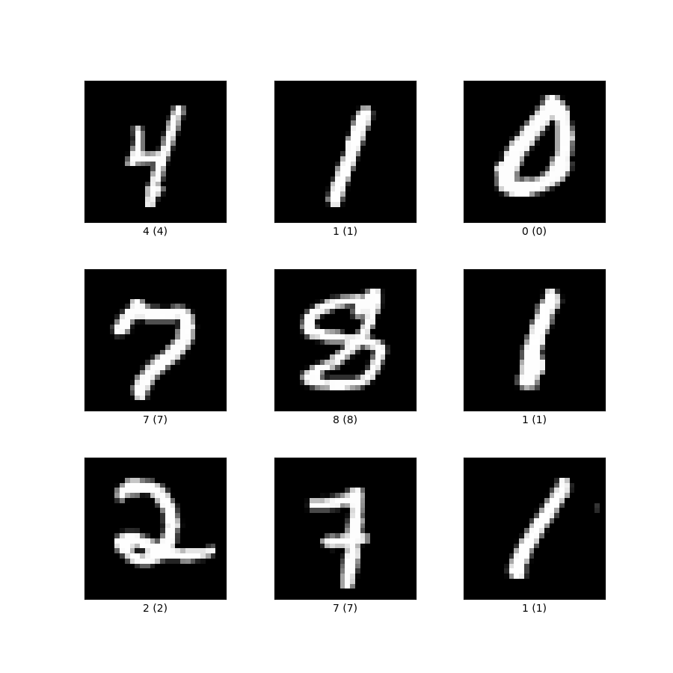
Figure 1 – dataset overview (mnist, n.d.)

